Title:
Clear Skies
Group name:
Team Awesome
Group members and role:
Ian Hirschfeld – models, textures and visual code
Ben Johnson – camera and projectile code
Adam Gressen – enemy movement and collision code
Vision and Idea:
The player will be defending a tower from attackers who come by land and air. We’ll have projectiles, enemies, and a central tower. The object is to hit the enemies with projectiles before they reach the tower. Each enemy killed will reward the player with points while each enemy that reaches the tower will cause damage. We were thinking along the lines of the following three existing games:
Incoming:
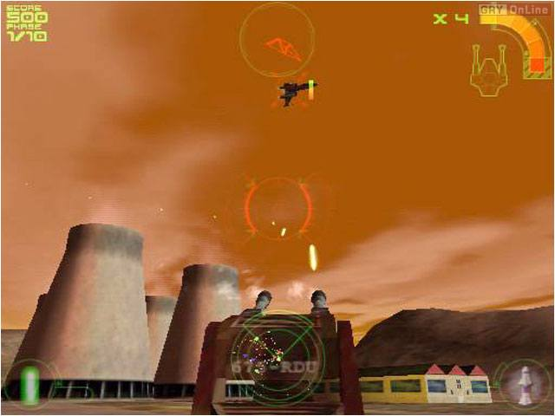
Armed and Dangerous:
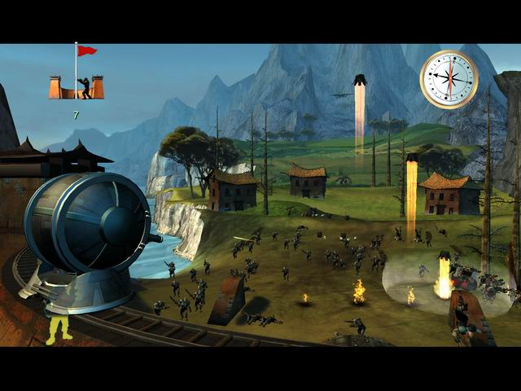
Heavy Gunner:
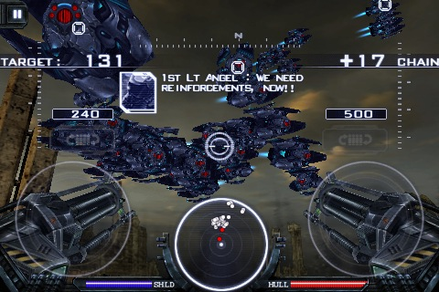
Specification of Requirements:
The enemies will advance towards the tower and cause damage when they reach the tower. If you let so many enemies reach the tower, then the game is over. For each enemy you kill you gain points. The tower will have the camera behind it and the player will be able to shoot projectiles at enemies that destroy them when hit. The camera rotates with the tower’s turret, left and right and up and down.

